The active site of an enzyme:
A. Never changes
B. Forms no chemical bond with substrate
C. Determined by structure and the specificity of the enzyme.
D. They are non-specific in their action
ANSWER: C
Which step causes activation of the catalytic site of an enzyme?
A. Change in pH of the surroundings
B. Formation of enzyme-substrate complex
C. Change in the charge of the active site
D. Change in temperature
ANSWER: B
the ________ is the region of an enzyme where substrate molecules bind
A. Non-catalytic site
B. Functional site
C. Active site
D. Binding site
ANSWER: C
How many functional regions are there on the active site?
A. 2
B. 3
C. 4
D. 5
ANSWER: A
Binding site is the _________ region of active site
A. Structural
B. Functional
C. Basic
D. Central
ANSWER: B
Catalytic site is the _________ region of active site
A. Structural
B. Functional
C. Basic
D. Central
ANSWER: B
Amino acid residues that form temporary bonds with the substrate constitute:
A. Binding site
B. Catalytic site
C. Non-catalytic site
D. Allosteric site
ANSWER: A
Amino acids which cause the conversion of substrate into product constitute the:
A. Binding site
B. Catalytic site
C. Non-catalytic site
D. Allosteric site
ANSWER: B
Each _________ is evolved to be optimised to bind a particular substrate and catalyse a particular reaction, resulting in high specificity.
A. Enzyme
B. Functional site
C. Active site
D. Binding site
ANSWER: C
The specificity is determined by the arrangement of:
A. Amino acids in the active site
B. Active site and the structure of substrate
C. Amino acids within the active site and the structure of the substrates
D. Protein sequence of substrate
ANSWER: C
Once the substrate is bound and oriented to the active site:
A. Product can be formed
B. ESC formed
C. Catalysis can begin
D. None of these
ANSWER: C
Catalytic residues of the site interact with the substrate to ______________ of a reaction and thereby make it proceed faster
A. Maintain the activation
B. Lower the activation energy
C. Increase the activation
D. Double the activation
ANSWER: B
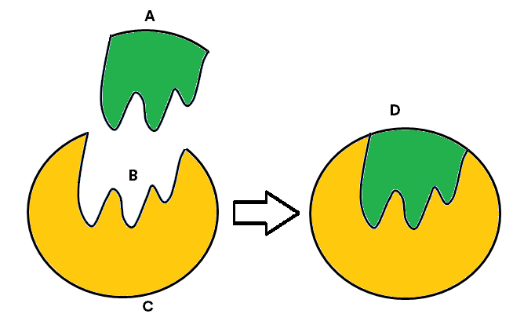
Observe the diagram and identify what structure A represents:
A. Substrate
B. Enzyme-substrate complex
C. Enzyme
D. Active site
ANSWER: A

Observe the diagram and identify what structure B represents:
A. Substrate
B. Enzyme-substrate complex
C. Enzyme
D. Active site
ANSWER: D

Observe the diagram and identify what structure C represents:
A. Substrate
B. Enzyme-substrate complex
C. Enzyme
D. Active site
ANSWER: C

Observe the diagram and identify what structure D represents:
A. Substrate
B. Enzyme-substrate complex
C. Enzyme
D. Active site
ANSWER: B
The __________ is usually a groove or pocket of the enzyme
A. Substrate
B. Product
C. ESC
D. Active site
ANSWER: D
If the enzyme changes the active site the rate of reaction will undergo which of the following changes?
A. Decrease
B. Increase
C. Remains same
D. None of these
ANSWER: A
The non-protein part of an enzyme is:
A. Prosthetic group
B. Co-factor
C. Co-enzyme
D. All of these
ANSWER: D
Which one forms the raw material for coenzymes?
A. Vitamins
B. Carbohydrates
C. Proteins
D. Metals
ANSWER: A
NAD, NADP, FAD and ATP are considered as:
A. Co-enzyme
B. Co-factor
C. Allosteric
D. None of these
ANSWER: A
Cofactor can be categorized into:
A. Prosthetic group
B. Coenzymes
C. Both A and B
D. None of these
ANSWER: C
If organic cofactors are tightly bound to an enzyme it is:
A. Prosthetic group
B. Coenzymes
C. Activator
D. Inhibitor
ANSWER: A
If organic cofactors are loosely attached with an enzyme it is:
A. Prosthetic group
B. Coenzymes
C. Activator
D. Inhibitor
ANSWER: B
Which of the following is an inorganic cofactor?
A. $Fe^{++}$
B. $Mg^{++}$
C. $Cu^{++}$
D. All of these
ANSWER: D
Magnesium is an inorganic activator for the enzyme:
A. Manganese
B. Carbonic anhydrase
C. Phosphatase
D. Hexokinase
ANSWER: C
The cofactor may be:
A. Inorganic molecules
B. Organic molecules
C. Both A and B
D. None of these
ANSWER: C

